

**User Agreement Guide – Version 1.0**

JNA Radio Services

Table of Contents

1. Introduction 3

1.1 What is InterRadio? 3

1.2 System Overview 3

2. System Features 4

2.1 Internet Radio 4

2.2 Playback Toolbar 4

2.3 Genre Toolbar 4

2.4 Favorite Stations 5

2.5 Station List 5

2.6 Custom Radio Station 5

2.6 Current Stations List 6

2.7 Country Selection 6

# Introduction

## 1.1 What is InterRadio?

InterRadio is an internet radio application, currently able to stream over 100 radio stations from Europe, Oceania, North America, South America, and Africa. Stations provided by InterRadio are broken into four “Genres”: Sports, Music, News, and General. The application allows the user to select what “Genre” of radio they would like to listen to, and filters available stations accordingly. InterRadio allows users to listen to radio stations from around the world according to their set filters.

## 1.2 System Overview

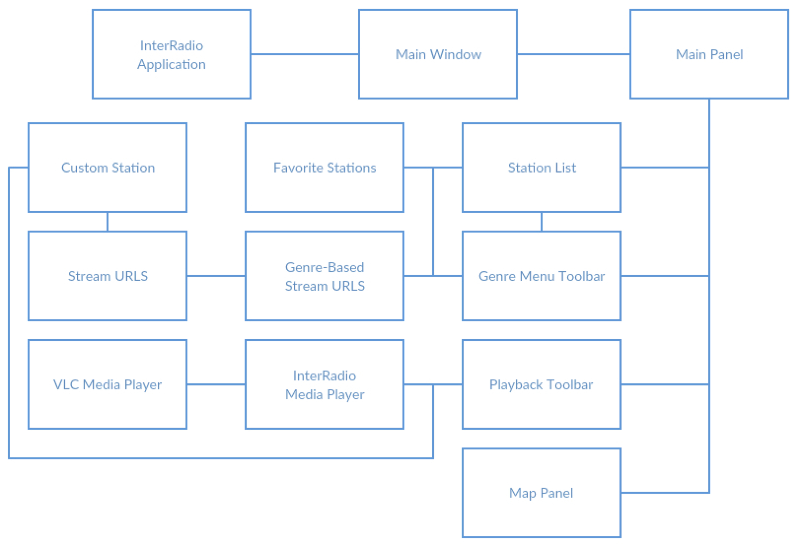

*Table 1.1: Application Structure*

Using IntelliJ IDEA, InterRadio is a java-based application. As shown above, it uses stream URLS collected from different radio stations and VLC Media Player files to create the foundations of the application. The InterRadio Media Player is a media player that works on both Windows and Macintosh OS X by incorporating both sets of VLC files into one player.

# System Features

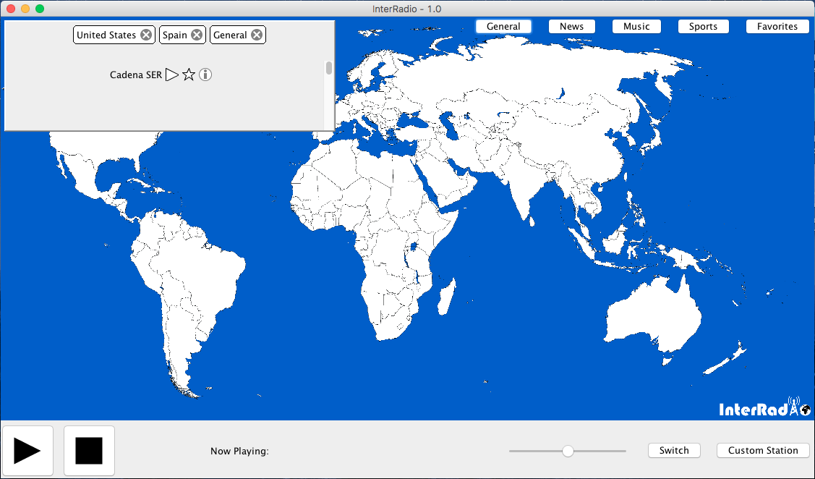

## 2.1 Internet Radio

InterRadio uses internet streams from national and regional radio stations from different countries. Using stream URLs, InterRadio provides live broadcasts from 100+ radio stations. These stream URLs are then divided into genres for the user to select (See 2.3 Genre Toolbar). For the app to receive radio, users must be connected to the internet.

## 2.2 Playback Toolbar

The playback toolbar allows the user to control the audio playback of the application. This toolbar is situated at the bottom of the window and contains: a slider to adjust the volume of the radio, a button to play and pause the radio, a button to switch the audio source, a stop button to end the audio playback (without exiting the app), a display to show the current radio selected, and a ‘Custom Station’ button (See 2.6 Custom Radio Station). The “Switch” button cycles through stations in the currently selected tags. The play/pause button allows users to pause the stream, and later On startup, all stations are available to be cycled through, until a user selects a specific “Genre”.

## 2.3 Genre Toolbar

The genre toolbar allows the user to choose which “Genre” of radio they would like to have access to, and filters all available stations accordingly. Users can select a single “Genre”, multiple “Genres”, or all “Genres” to be displayed and to be made ready to play. Additionally, stations that fall into more than one “Genre” will be filtered when any of its respective “Genres” have been selected. The genre toolbar also features a ‘Favorites’ button, which allows users to view favorited stations in the Station List (See 2.5 Station List).

## 2.4 Favorite Stations

On the station list (See 2.5 Station List), there is a star-shaped button that when pressed, adds that station to your favorites. The tag on the genre toolbar (See 2.3 Genre Toolbar) can be selected to display your favorite radio stations on the station list. Users can favorite and un-favorite stations to update their current favorites.

## 2.5 Station List

On the top-left corner of the screen is a panel displaying a list of stations. Based on the tags selected using the genre toolbar (See 2.3 Genre Toolbar), the station list displays the stations that fit those specifications. There are displayed on at a time, with three buttons. A play button that allows stations to play the station displayed on the panel. A star button saves the displayed station to the users ‘Favorites’. Finally, an information button, which will be implemented in the future to show the specifications of a radio station and any information packed with the stream (such as the name of the song being played, station program, artist name, etc).

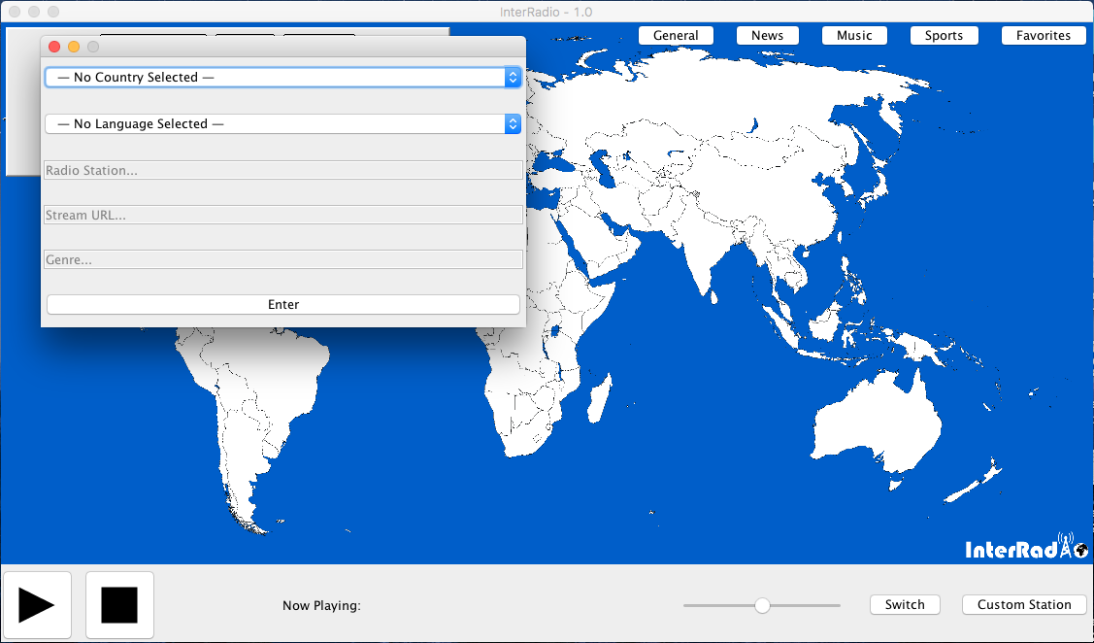

## 2.6 Custom Radio Station

By clicking on the ‘Custom Station’ button on the playback toolbar (See 2.2 Playback Toolbar), a window is launched displaying a form that can be filled out to enter a custom station. The form allows users to select a country and a language based on a series of choices. It has three text boxes that allow users to input the stream URL, the station name, and genres. The custom radio station form is programmed to ensure that stream URLs are valid before modifying the application’s database.

## ::::Desktop:Screen Shot 2016-12-23 at 8.52.17 PM.png

## 2.6 Current Stations List

InterRadio has a menu implemented into the application. The menu item ‘Stations’ brings down a menu that contains a tab ‘View Current Stations’. By clicking on that tab, a new window is launched showing a table containing the data regarding the current stations in the application. In the future, the table will be editable so that users can delete custom stations.

## 2.7 Country Selection

The map on the main window displays a map of the world. To listen to a radio station from a specific country, users simply have to click on the country to listen to. At the moment, 28 countries are supported, but JNA Services plans to update the application to include all the countries on the map.